 أكاديمي ة الشرو ق

EL SHOROUK ACADEMY

### High Institute of Communication & computing Engineering

**Smart Home (Automated system)**

##### By:

**Ahmed Osama Fawzy Amr Hamdy Abdel-Halim Ahmed Mohamed Hussien Ahmed Mostafa Ebeed Mohamed Ashraf Gamal Omar Nagy Shaker**

##### Under supervision of:Dr.Mahmoud Rehan Assisting supervisor:Eng. Sahar

Academic year

**2021**

**Acknowledgements**

Vitally, gratitude and appreciation must be conveyed to our supervisor, Dr. Mahmoud Rehan. His continued support and guidance were critical factors in the development of this project. Moreover, we would like to express our admiration and thanks to the teaching assistants who have helped us a lot on the technical and moral levels, especially Eng.Sahar.

**Abstract**

Home automation system achieved great popularity in the last decades as it increases the comfort and quality of life. In this project, an overview of current and emerging home automation systems is discussed. Nowadays most home automation systems consist of a smartphone microcontroller and some sensors & actuators to perform the program instructions flashed on the microcontroller which will be uploaded/downloaded to/from the cloud. A smartphone application is utilized to control and screen the home appliances using the UART Communication protocol and we will utilize the type of wireless communication techniques “Wi-Fi” to connect it to an IoT cloud which will gather all the data and process it and then executes whatever it should.

.

Table of Contents

Chapter 1: Introduction 8

* 1. Introduction 1
  2. Project objectives 2
  3. Project Development Methodology 3
  4. Project Phases 7
  5. Project Plan 8
  6. Technologies & Tools 9
  7. Definitions, Acronyms and Abbreviations 10

Chapter 2: Background andliterature survey 11

* 1. Background 12
  2. Literature survey 13
     1. Problem Definition 13
  3. Hardware Requirements 14
     1. SMARTHOME 15

Smart-Home Components 16

1- LCD 16x2 17

* + - 1. Auto cooling system 18
      2. Auto-Gardening system 19

19

* + - 1. Lighting System 20
      2. Fire System 21
      3. Earthquakes System 22
      4. Fence Security Sensor 23
      5. Auto-Curtain Control 24
      6. Water Tank System 25
      7. Garage Security System 26

Chapter 3 27

Analysis Phase 27

* 1. Business Models 28
  2. System Description 29
     1. System Context & Scope 29
     2. System Models 30
        1. Use Cases 30

3.3.2.1 Sequence Diagram 31

* + 1. Functional Requirements 32
    2. Non-Functional Requirements 33

Chapter 4 34

Design Phase 34

* 1. System Architecture 35
  2. Database Description 36
  3. Software Design 39
     1. Mobile Application 39

Chapter 5: ImplementationPhase 56

* 1. Libraries: 57

LiquidCrystal.h 57

Servo.h: 57

DHT.h: 57

Wire.h: 57

SPI.h: 57

elapsedMillis.h: 58

arduino-timer.h 58

Adafruit_PN532.h 58

* 1. Functions: 58

bool AutoGardeningSystem_task(void); 58

void FienceSecuritySystem(void); 59

void EarthaquackAlarm(int EarthquackSensorReading); 59

void FireSystem_Task(int FlameSensorReading,int FlameSensorReading2,int

FlameSensorReading3); 59

void Alarm(); 59

void AlarmStop(); 59

void AutoLightingSystem_Task(); 59

bool AutoCoolingSystem_Task(void); 60

void GarageSystem(void); 60

void MobileControl_Functions(char Mobile_Data); 60

void LDRCurtainControl_Task(int LDRReading); 60

bool LCD_Print_Task (void); 60

Chapter 6 61

Testing Phase 61

Testing 62

* 1. Testing Approach 63
  2. Testing Environment 77
  3. Testing Results 78

Chapter 7: Conclusions & Recommendations 80

* 1. Summary of achieved results 81
  2. Possible extensions & Further developments 81

Chapter 8:References 82

**List of Figures:**

Figure 1 (1-1 Water fall model) 3

Figure 2(1-2 Project Plan) 8

Figure 3(2-1 Hardware Requirements) 14

Figure 4(2-2 Smart Home) 15

Figure 5(2-3 LCD) 17

Figure 6 (2-4 Auto Cooling System) 18

Figure 7(2-5 Auto-Gardening System) 19

Figure 8(2-6 Lighting System) 20

Figure 9(2-7 Fire System) 21

Figure 10(2-8 Earthquake System) 22

Figure 11(2-9 Home-Theft Sensor) 23

Figure 12(2-10 Auto Curtain Control) 24

Figure 13(2-11 Water Tank system) 25

Figure 14(2-12 Garage Door System) 26

Figure 15(3-1 System context & scope ) 29

Figure 16(3-2 UseCase Model) 30

Figure 17(3-3 Sequence Diagram) 31

Figure 18(3-4 System arch) 35

Figure 19(3-5 Types of testing) 64

Figure 20(3-6 Proteus Simulation) 78

**List of Tables:**

Table 1(LCD) 17

Table 2(Auto cooling system) 18

Table 3(Auto-gardening system) 19

Table 4(auto lighting ) 20

Table 5(fire system ) 21

Table 6(Earthquakes system ) 22

Table 7(fence security sensor) 23

Table 8(Auto-curtion system) 24

Table 9(TANK SYSTEM) 25

Table 10(Garage system)0 26

# Chapter 1: Introduction

## Introduction

After the development that took place over the past late years and the enormous technological development in various activities and fields, mankind had to go to the automation of their homes A smart home is a habitation that utilizes

web-connected devices to enable far off monitoring and management of appliances and systems, for example, lighting and heating Smart home innovation, also often alluded to as home automation gives homeowners security solace, accommodation, and energy efficiency by allowing them to control smart devices often by a smart home app on their smartphone or another organized gadget Apart of the web of things (IoT) smart home systems and devices often operate together, sharing buyer usage data among themselves and automating actions based of the homeowners.

The home automation framework achieved great popularity in the last decades as it increases the solace and quality of life. In this undertaking, a diagram of current and arising home automation systems is examined. Nowadays most home automation systems consist of a smartphone microcontroller and some sensors and actuators to play out the program instructions flashed on the microcontroller which will be uploaded/downloaded to/from the cloud. A smartphone application is utilized to control and screen the home appliances utilizing the UART Communication protocol and we will utilize the type of wireless communication techniques "Wi-Fi" to connect it to an iot cloud which will gather all the data and process it and then executes whatever it should.

## Project objectives

##### 1- Security:

* Using security cameras: that allows customers to monitor their homes or factories distantly when they are not in it.
* Using fire alarm: which gives an alarm in case of a fire happening.
* Using smart machine plugs: allows customers to disable electricity through their cell phones so as not to impede and along these lines leads to fire. **2- Saving energy & electricity as the government seeks to rationalize consumption of energy and electricity.**
* Using smart machine plugs: allows customers to disable electricity through their cell phones when they are in the department and during the dozing time.
* They also can plan their dozing hours consistently.
* Obviously, the lighting system we use would assist us with saving power consumption.

##### Comfortable:

* Controlling each peripherals in the home utilizing a virtual assistant or a mobile application will grab the comfortable for the homeowners.

##### Saving money:

* Saving power consumption using these smart systems in our home will definitely save our money.

##### Helping elderly people and people with special needs:

* Controlling every single peripheral in the home using a virtual assistant or a mobile application will grab the comfortable to the elderly people and people with special needs while easily say
* “open the door” to open the door look while sitting on their chair or by seeing who is out the door using camera and the mobile application then click the open button on the touch screen or don’t open

## Project Development Methodology

The main characteristics of the Waterfall model are a sequential progression through the different stages of a project from initiation to the delivery phase. The waterfall model does have its limitations and because of this, there have been many spins off models created over the years.

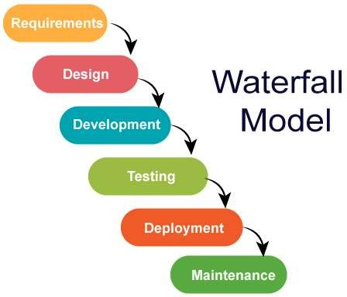

*Figure 1 (1-1 Water fall model)*

The Waterfall model consists of the following phases:

* Requirements
* Analysis
* Design
* Implementation
* Testing
* Maintenance

The waterfall model used with the SDLC progresses through the six phases. You can picture this process as a waterfall with one phase flowing into the next.

##### Requirements Phase

the purpose of the initiation phase is to conduct an initial high-level investigation of the business need and come up with a recommendation for the solution. Once approved by the management team, stakeholders, client or project sponsor, it will proceed to the next phase.

##### Analysis Phase

the purpose of the requirements analysis phase is to conduct a detailed analysis of the current business needs and identify what options is availableto achieve those business needs. During the Analysis Phase, the Business Analyst will create the Business Requirements Document (BRD).

##### Design Phase

the purpose of the design phase is to identify and document a solution thatwill be constructed including technical and procedural specifications. A design document will be created that should include but not limited to technical, environmental, data, program, procedural, testing specifications.

##### Implementation Phase

The construction or development phase is where a resource will take thedesign document created during the design phase and translate it into a functional program or system.

##### Testing Phase

The purpose of the testing phase is to test the system and related proceduresthat it meets the requirements specified by the stakeholders and documentedin the BRD, design plan, and testing plan.

##### Maintenance Phase

the purpose of the implementation phase is to release a fully tested and operational product to an end user or customer. The product should meet allthe requirements that were documented in the BRD and pass the testing phase before it can be released to a production environment.

##### Advantages of waterfall model:

* This model is simple and easy to understand and use.
  + It is easy to manage due to the rigidity of the model – each phase has specific deliverablesand a review process.
* In this model phases are processed and completed one at a time. Phases do not overlap.
  + Waterfall model works well for smaller projects where requirements are very wellunderstood.

##### Disadvantages of waterfall model:

* + Once an application is in the testing stage, it is very difficult to go back and changesomething that was not well-thought out in the concept stage.
* No working software is produced until late during the life cycle.
* High amounts of risk and uncertainty.
* Not a good model for complex and object-oriented projects.
* Poor model for long and ongoing projects.
* Not suitable for the projects where requirements are at a moderate to high risk of changing.

##### Why waterfall Model is for our project?

Product definition is stable.

The requirements are very well known, clear and fixed. There are no ambiguous requirements

Technology is well understood.

## Project Phases

Step 1: Electronic Parts

Step 2: Enclosure Plan

Step 3: Electronics Plan

Step 4: implement embedded

Step 5: test

Step 6: implement android

Step 7: test with embedded

Step 8: test whole project

Step 9: IoT phase

Step 10: Build

## Project Plan

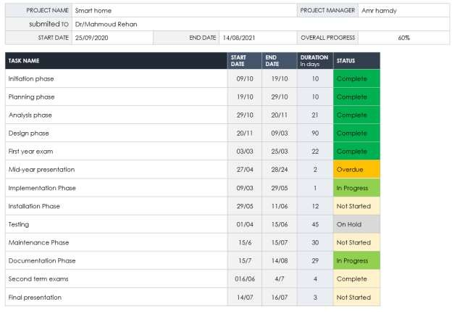

*Figure 2(1-2 Project Plan)*

## Technologies & Tools

* + - IDE

Visual studio code Arduino

* + - Software React native
    - Hardware Arduino c
    - Database & Server Firebase

## Definitions, Acronyms and Abbreviations

This is the Abbreviations of the document:

* Universal asynchronous receiver-transmitter (UART)
* Internet of things (IOT)
* Wireless Fidelity (Wi-Fi)
* Systems development life cycle(SDLC)
* Business requirements document (BRD)
* Direct current (DC)
* Infrared sensors (IR)
* Single-Pole Double-Throw (SPDT)
* Internet protocol (IP)
* Alternative current (AC)
* Liquid crystal display (LCD)
* Light emitting diode (LED)
* Light dependent resistor (LDR)
* Potential of hydrogen ( PH)

# Chapter 2: Background and literature survey

## Background

A smart home’s devices are connected with each other and can be accessed through one central point—a smartphone, tablet, laptop, or game console. Door locks, televisions, thermostats, home monitors, cameras, lights, and even appliances such as the refrigerator can be controlled through one home automation system. The system is installed on a mobile or other networked device, and the user can create time schedules for certain changes to take effect.

Smart home appliances come with self-learning skills so they can learn the homeowner’s schedules and make adjustments as needed. Smart homes enabled with lighting control allow homeowners to reduce electricity use and benefit from energy-related cost savings. Some home automation systems alert the homeowner if any motion is detected in the home when they're away, while others can call the authorities—police or the fire department—in case of imminent situations.

Once connected, services such as a smart doorbell, smart security system, and smart appliances are all part of the internet of things (IoT) technology, a network of physical objects that can gather and share electronic information. Security and efficiency are the main reasons behind the increase in smart home technology use.

Smart homes can feature either wireless or hardwired systems—or both. Wireless systems are easier to install. Putting in a wireless home automation system with features such as smart lighting, climate control, and security can cost several thousand dollars, making it very cost-friendly

## Literature survey

## Problem Definition

* Elderly and the handicapped user faced problem to manually access control of light and fan instead of automation process.
* The condition and safety of the house is unknown when the user is away from the house for certain days.
* The complexity of installing and high cost configuration of previous home
* automation system leads to not receive much demand and attention.

## Hardware Requirements

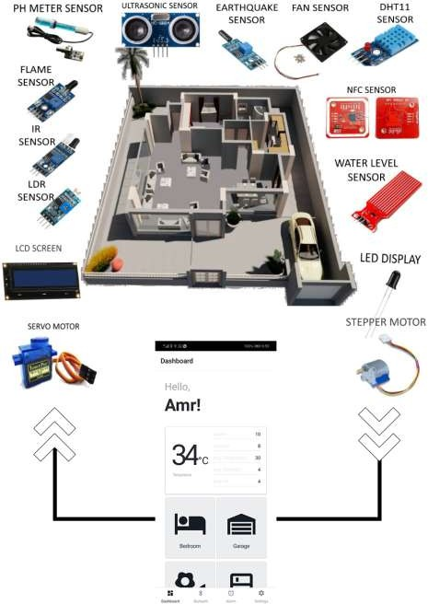

*Figure 3(2-1 Hardware Requirements)*

## SMARTHOME

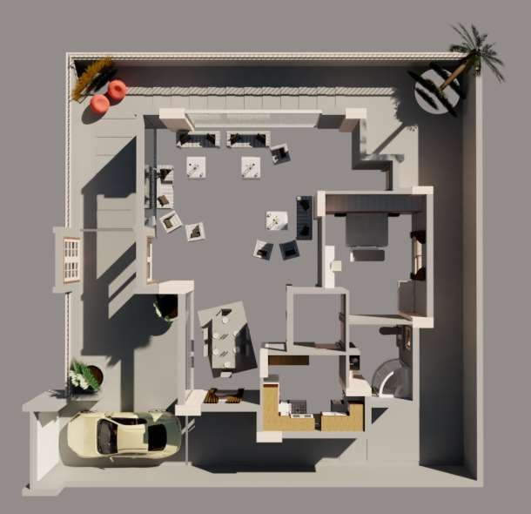

*Figure 4(2-2 Smart Home)*

## Smart-Home Components

The smart home consists of a variation of system, each system consists of sensors with a different purpose located all around the house taking data inputs from the surrounding environment to be analyzed & used to take actions later, turning off pump, closing doors, turning fan on, ….etc

The components of Smart-Home that will be used are as follow:

1. LCD 16x2
2. FAN
3. DHT-11

4. YL-38

1. PUMP
2. LDR
3. Servo-motor
4. Stepper-motor
5. PIR
6. PH-meter 11.Water-level Sensor 12.SW-10801

13.Flame-Sensor 14.RC520

15.IR-Sensor 16.Ultra-Sonic 17.Bluetooth 18.MCU

19.Mobile Application

Now please allow us to walk you through each one of those components, by giving you an overview of each one explaining what they are and why we chose them for our project.

## LCD 16x2

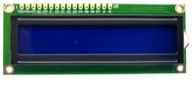

*Figure 5(2-3 LCD)*

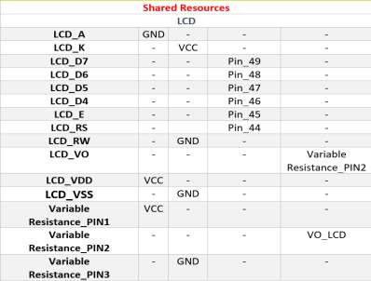

**Description: -**

*Table 1(LCD)*

LCD is a flat panel display technology commonly used in TVs and computer monitors. It is also used in screens for mobile devices, such as laptops, tablets, and smartphones.

LCD in the house to tell the status all the time including : the current temperature, humidity water level in the tank , ph of the water, weather the garden needs watering or not..etc..

## Auto cooling system

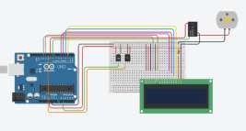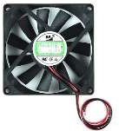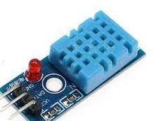

*Figure 6 (2-4 Auto Cooling System)*

##### Objectives:

* Auto-cooling System considering the power saving strategies.

##### Flow Of Data in the System:

Environment Sensing Stage: The system sense the Humidity and Temperature in the Air particles of the rooms through Humidity & Temp SENSOR (DHT11).

*Table 2(Auto cooling system)*

* Control Stage: Microcontroller (Arduino mega2560 robotdyn) will Receive the surrounding status then send the received data to the LCD ,Virtual Assistant , Mobile Application (Through ESP01 WiFi Module) , and power on the DC Fan in the suitable speed,.

##### Actuation Stage:

* LCD (16*2) will show the status of the of room temp and humidity.
* Mobile Application will Show message on the screen of the mobile alerting the user of the status of the room temp and then give the user the option to don’t open the fan.
* Virtual Assistant will wait for a message from user to power the fan off

## Auto-Gardening system

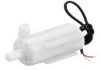

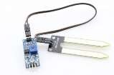

*Figure 7(2-5 Auto-Gardening*

*System)*

*Table 3(Auto-gardening system)*

##### Objectives:

* Monitoring The Gardening.

##### Flow Of Data in the System:

* Environment Sensing Stage: The system senses the Humidity and moisture in the soil of the garden through Soil Moisture Sensor Module.
* Control Stage: Microcontroller (Arduino UNO) will Receive the surrounding status then send the received data to the LCD , Virtual Assistant and Mobile Application (Through ESP01 WiFi Module).

##### Actuation Stage:

* LCD (16*2) will show the status of the garden.
* Mobile Application will Show message on the screen of the mobile alerting the user of the status of the garden if needed to be watered.
* Virtual Assistant will Send a voice message in the home through sound system for alerting the user.

1. 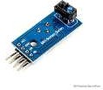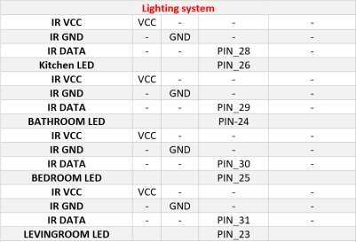**Lighting System**

* **Objectives:**

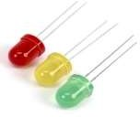

*Figure 8(2-6 Lighting System)*

*Table 4(auto lighting)*

* Lighting the Home Sections (Rooms,Toilets,kitchen,...etc) , Consedring the Power Saving Strategies.
* **Flow Of Data in the System:**
* Environment Sensing Stage: The system senses the presence of a person in the room through the PIR Sensor.
* Control Stage: Microcontroller (Arduino mega2560 robotdyn) will Receive the surrounding status then analyze if there is someone arount light up the engaged LED.
* **Actuation Stage:**
* LED_ON/OFF

### Fire System

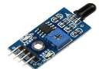

##### Objectives:

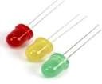 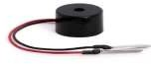

*Figure 9(2-7 Fire System)*

*Table 5(fire system )*

* Security System used to Send alerts and instruction during Fire.

##### Flow Of Data in the System:

* Environment Sensing Stage: The system senses the fire the whole home corners to track the best exit way while fire occurs in the home through the flame sensor module C01.
* Control Stage: Microcontroller (Arduino mega2560 robotdyn) will Receive the surrounding status then send the received data analyze it then decide the best exit then send it to the Virtual Assistant and Mobile Application (Through ESP01 WiFi Module) and Release the alarm (power on the LEDS & BUZZER).

##### Actuation Stage:

* Mobile Application will Show message on the screen of the mobile alerting the user And send message to the assistant.
* Virtual Assistant will Send a voice message in the home through sound system for alerting the user and tell him the best exit.

### Earthquakes System

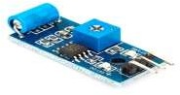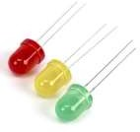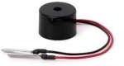

*Figure 10(2-8 Earthquake System)*

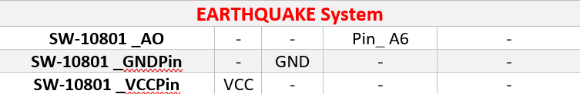

##### Objectives:

*Table 6(Earthquakes system )*

* Security System used to Send alerts and instruction during earthquakes.

##### Flow Of Data in the System:

* Environment Sensing Stage: The system senses the Vibrations (in the earthquake scale) in the whole home sections through the earthquake sensor (SW-10801).
* Control Stage: Microcontroller (Arduino mega2560 robotdyn) will Receive the surrounding status then send the received data to the Virtual Assistant and Mobile Application (Through ESP01 WiFi Module) and Release the alarm (power on the LEDS & BUZZER).

##### Actuation Stage:

* Mobile Application will Show message on the screen of the mobile alerting the user And send message to the assistant.
* Virtual Assistant will Send a voice message in the home through sound system for alerting the user and tell him the best instructions to follow.

### Fence Security Sensor

*Figure 11(2-9 Home-Theft Sensor)*

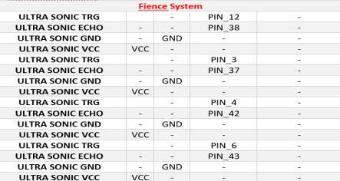

##### Objectives:

*Table 7(fence security sensor)*

* Security System used to Send alerts that there is an unknown person want to break into the home through the fence.

##### Flow Of Data in the System:

* Environment Sensing Stage: The system sense the obstacle from the top of the fence through the ultrasonic sensor.
* Control Stage: Microcontroller (Arduino UNO) will Receive the surrounding status then send it to the Virtual Assistant and Mobile Application (Through ESP01 WiFi Module) and Release the alarm (power on the LEDS & BUZZER).

##### Actuation Stage:

* Mobile Application will Show message on the screen of the mobile alerting the user , call 122 And send message to the assistant.
* Virtual Assistant will Send a voice message in the home through sound system for alerting the user.

## Auto-Curtain Control

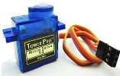

*Figure 12(2-10 Auto Curtain Control)*

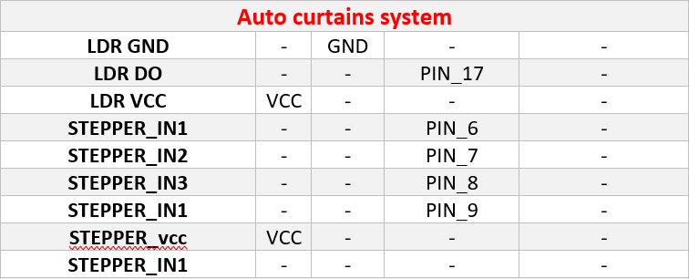

##### Objectives:

*Table 8(Auto-curtion system)*

* Auto-Curtain Control at the morning.

##### Flow Of Data in the System:

* **Environment Sensing Stage**

The system senses the presence of the sunlight outside the room through the outside allocated LDR sensor.

##### Control Stage

Microcontroller (Arduino UNO) will Receive the surrounding status then analyze if there is a sunlight the controller sends a pulse to servo to control the curtain.

##### Actuation Stage:

SERVO _forward /backward

## Water Tank System

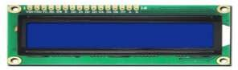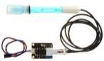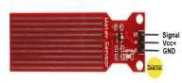

*Figure 13(2-11 Water Tank system)*

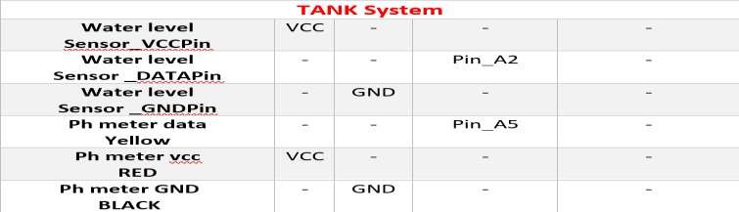

##### Objectives:

*Table 9(TANK SYSTEM)*

* Monitoring The water level in the tank and the water portability.

##### Flow Of Data in the System:

* Environment Sensing Stage: The system senses the water level in the tank through water leek level sensor and water portability.
* Control Stage: Microcontroller (Arduino UNO) will Receive the surrounding status then send the received data to the LCD , Virtual Assistant and Mobile Application (Through ESP01 WiFi Module).

##### Actuation Stage:

* LCD (16*2) will show the status of the garden.
* Mobile Application will Show message on the screen of the mobile alerting the user of the status of the garden if needed to be watered.
* Virtual Assistant will Send a voice message in the home through sound system for alerting the user.

## Garage Security System

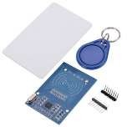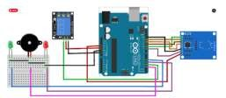

*Figure 14(2-12 Garage Door System)*

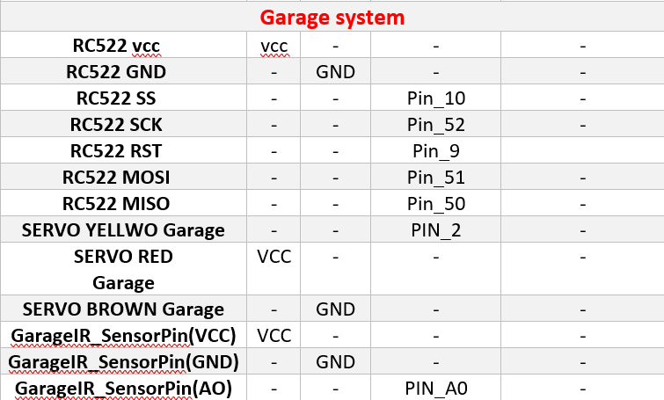

*Table 10(Garage system)0*

##### Objectives:

* Secured Door Unlock Garage.

##### Flow Of Data in the System:

* Environment Sensing Stage: The system senses the card or the tag through PN532 Module.
* Control Stage: Microcontroller (Arduino UNO) will Receive the surrounding status then unlock the smart lock.

##### Actuation Stage:

* Lock/Unlock

# Chapter 3: Analysis Phase

## Business Models

##### Hardware-as-a-Service

The most commonly cited business model for connected hardware start-ups relies on the sale or lease of a device that only works when a recurring fee is paid. Almost always this fee is a software license or service fee, sometimespaid on a time basis (annual, monthly) and sometimes on a metering basis (per byte or user). Hardware as a service companies optimize for high lifetime value through recurring fees rather than a hefty gross margin on theinitial sale.

##### The Software-as-a-Service (SaaS) Model

This model sees your software provided as a centrally hosted service that isonly accessible via a paid subscription. Subscriptions are usually user, transaction volume, or time based. SugarCRMs commercial offering followed the SaaS model, and it was only recently that they started offeringon-site deployments.

Although Hurok follows the as-a-Service model, theyoffer a platform solution, rather than a software solution.

1. **Peer-to-peer business model**

As per this model, a company acts as a middleman between two individual parties and create value for both demand and supply side. It’s different thana typical relationship of a business selling its services to consumers (B2B or B2C). It makes money through commissions. [Airbnb](https://bstrategyhub.com/airbnb-business-model-how-does-airbnb-make-money/) is the right example that allows transactions between hosts and hostess.

##### Which business model will we apply?

After studying previous models we will apply the Hardware-as-a-Service Model because This model is the most commonly cited business model for connected hardware startups relies on the sale or lease of a device that only works when a recurring fee is paid. So this model is appropriate for us.

## System Description

## System Context & Scope

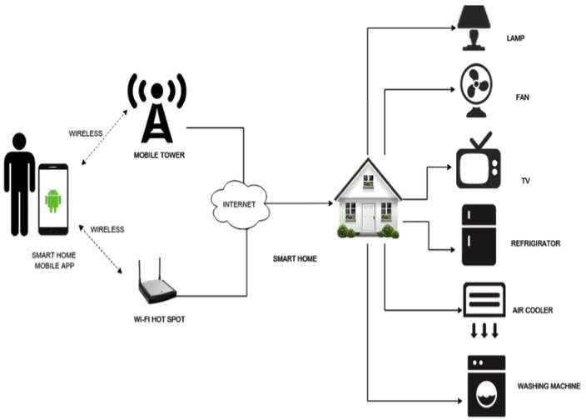

*Figure 15(3-1 System context & scope )*

## System Models

### Use Cases

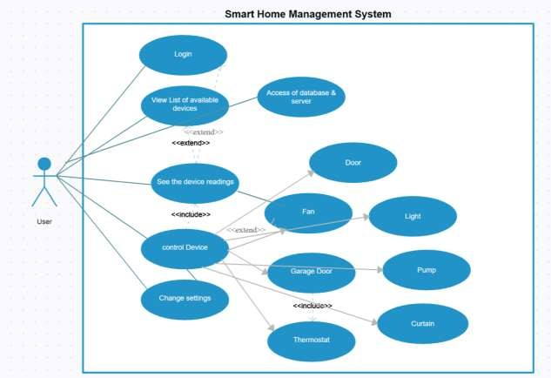

*Figure 16(3-2 UseCase Model)*

### 3.3.2.1 Sequence Diagram

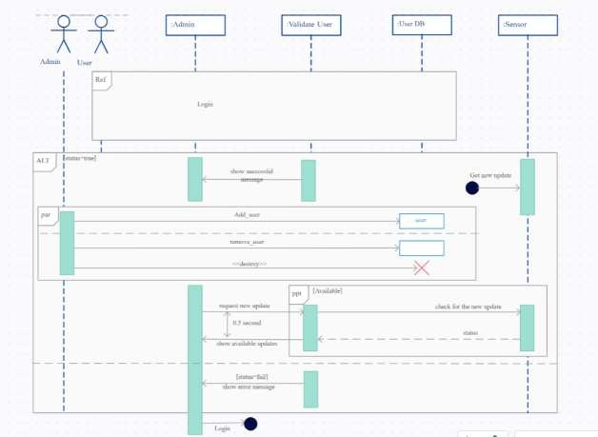

*Figure 17(3-3 Sequence Diagram)*

## Functional Requirements

##### For the users:

The user is expected to have a properly functioning smartphone. The user is expected to have the WIFI receiver on.

The user must have internet connection.

If all of above requirements are satisfied, the user will be able to: Track every thing happeining in his house

Give orders and be able to communicate with the devices

## Non-Functional Requirements

##### For the users:

The person who have the application in his cell phone should have internet access for emergency alerts

If all of above requirements are satisfied, the system should behave as following:

The system will alert the user if any thing bad happens in his house imeditally.

# Chapter 4: Design Phase

## System Architecture

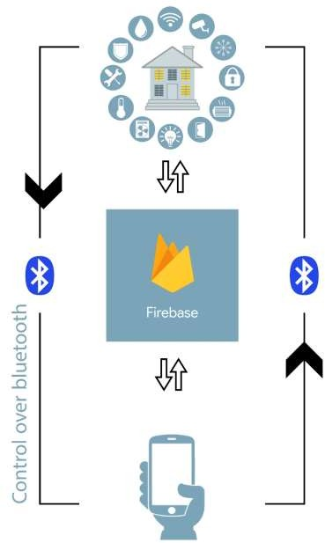

*Figure 18(3-4 System arch)*

## Database Description

We used Firebase database to send data between components.

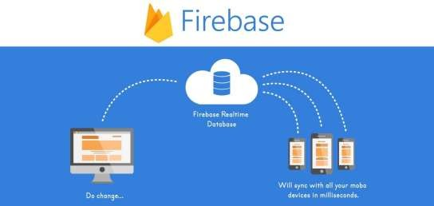

**The Firebase Realtime Database** is a cloud-hosted database. Data is storedas JSON and synchronized in realtime to every connected client. When you build cross-platform apps with our iOS, Android, and JavaScript SDKs, all of your clients share one Realtime Database instance and automatically receive updates with the newest data.

**The Realtime Database is a NoSQL** database and as such has different optimizations and functionality compared to a relational database. The Realtime Database API is designed to only allow operations that can be executed quickly. This enables you to build a great realtime experience thatcan serve millions of users without compromising on responsiveness.

#### Firebase Features:

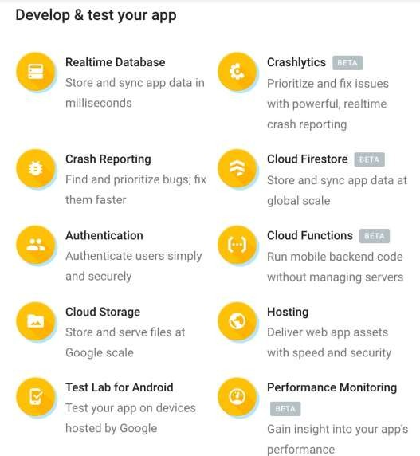

**Firebase Database Design:**

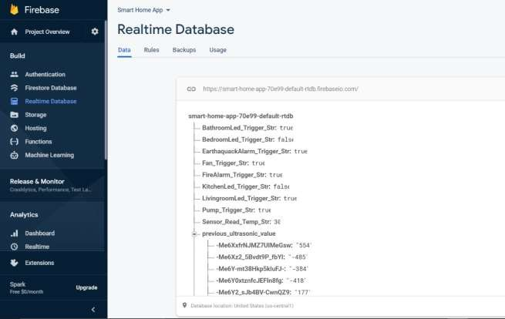

## Software Design

### Mobile Application

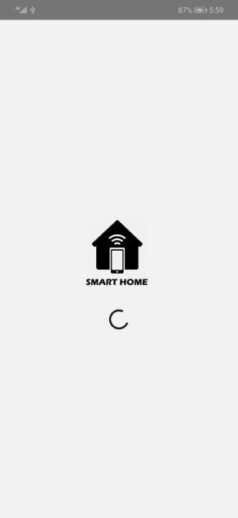

##### Start screen: Start Screen with project Logo

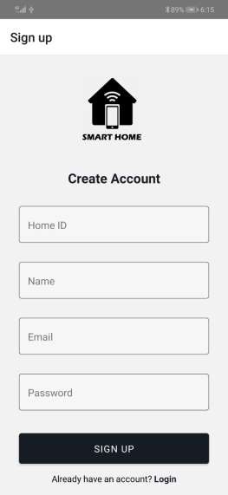

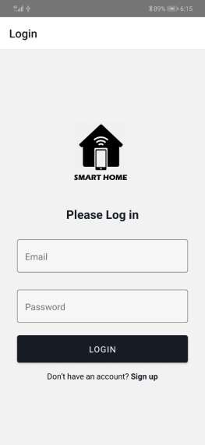

**Login Screen:** It takes email and password from the user and checks if the user is related to the home is matched

**Sign-up:** It takes some values from the user and user must have an home id that was given when installing the embedded system then stores them in database.

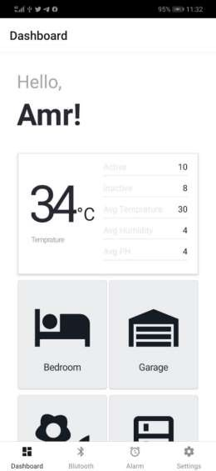

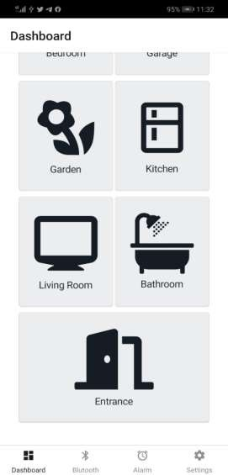

This is the first screen that appears when we login. There is a welcome message with a name that differs with different accounts and username.

We have next the status card that tracks different sensors in our home, in the right we have 5 status and in the left we have 3 status that we can switch between them if we click on it.

After then we have rooms that we can control the devices we have in each room.

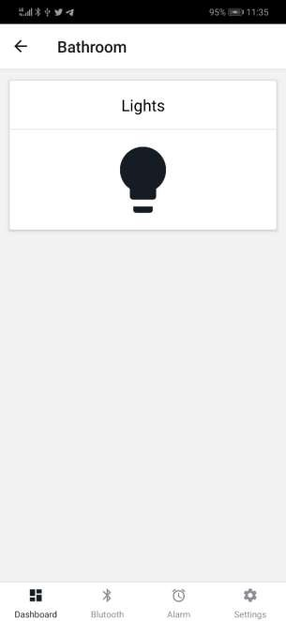

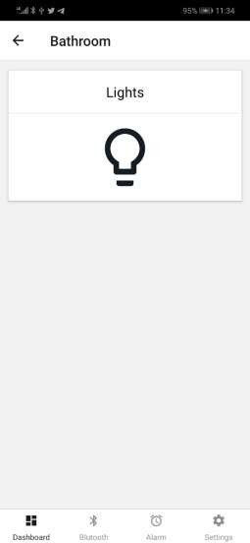

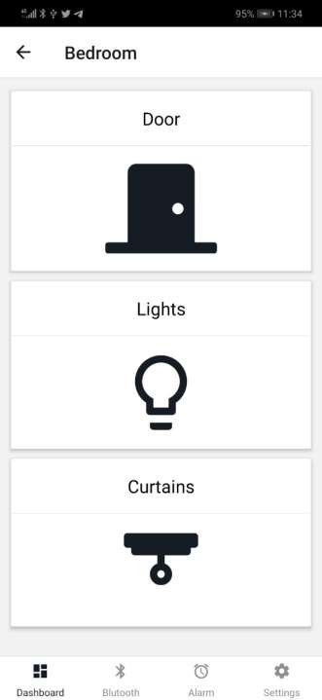

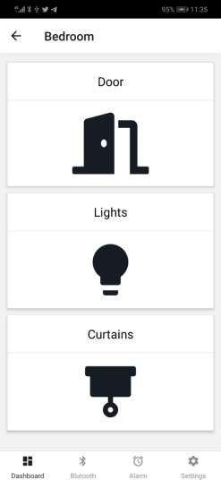

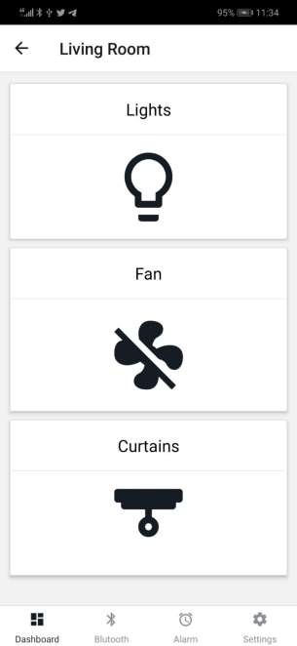

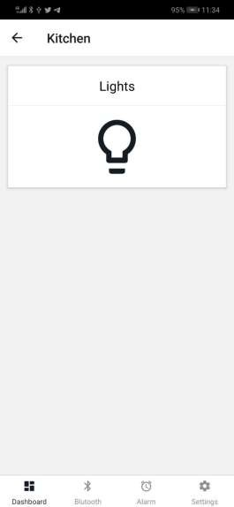

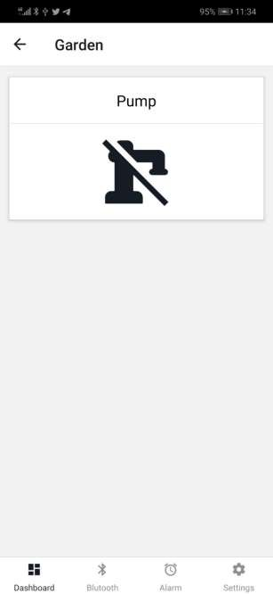

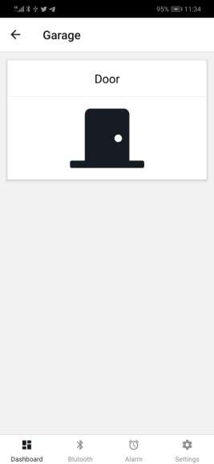

Here we show inside every device we have in each room. Each device we can click on the icon and we send data to the embedded sensors by Bluetooth or a server to control these sensors

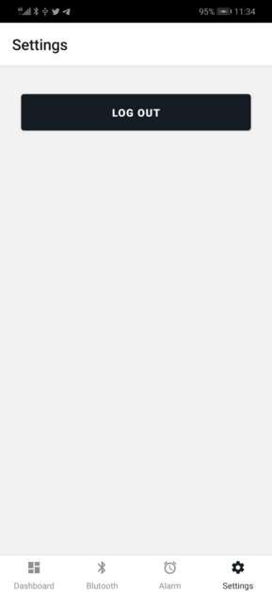

Here we can choose settings in bottom navigation if we want to log out from the application

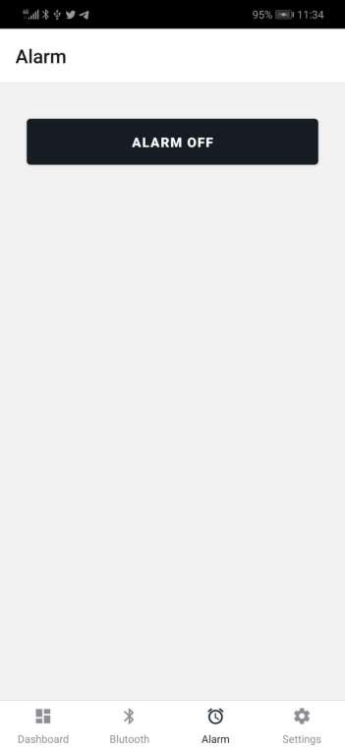

We can choose Alarm section from bottom navigation to control alarm tp switch off if it is triggered and we want to stop it

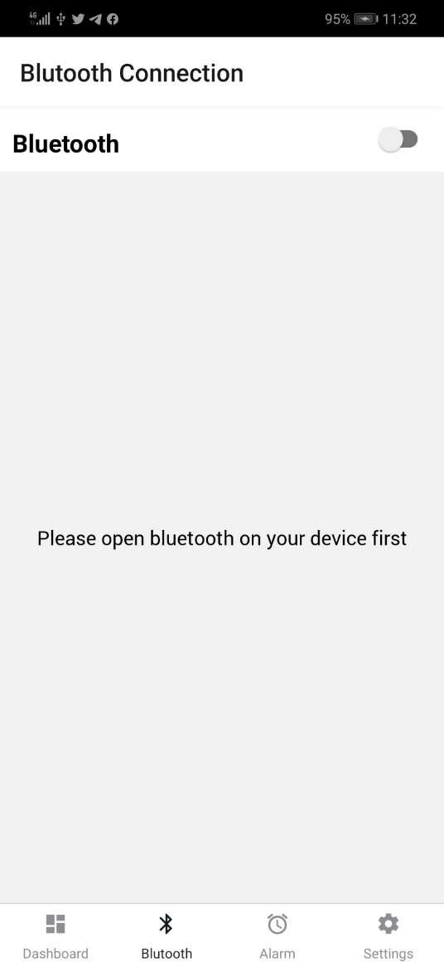

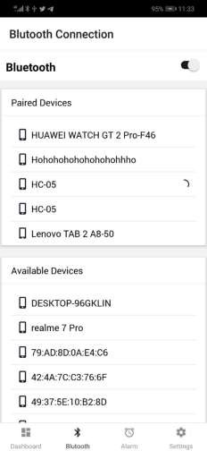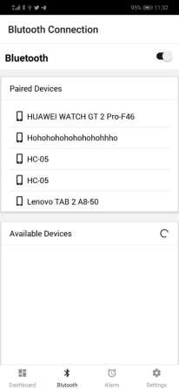

To be able to control sensor, we select Bluetooth in the bottom navigation and open device first in the phone. Then we switch the toggle in the two sections First section: we show paired devices

Second section: when Bluetooth is opened, we search for the available devices and we select any device to connect with

# Chapter 5: Implementation Phase

## Libraries:

### LiquidCrystal.h :

This library is used in LCD with functions such as:

lcd.begin(x,y); // which initializes the lcd and the position to start displaying in. lcd.setCursor(x,y); // to set the cursor position.

lcd.clear(); //to clear the lcd in order to write a new thing. lcd.println(""); or lcd.print(" "); //is used to write on the lcd.

### Servo.h:

This library is used in servo with functions such as:

Servo myServo; //Create the Servo Object. myServo.attach(ServoPin); //INITIALIZES the SERVO. Servo.write(0-180); //moves the servo base on the angle you pass to it.

### DHT.h:

DHT dht(DHTPIN, DHTTYPE); // Creats a DHT object dht.begin(); //INITIALIZE THE TEMP SENSOR

dht.readTemperature(); // reads the outside temperature to be displayed on the lcd later and used in the auto cooling system.

dht.readHumidity(); reads the outside humidity to be displayed on the lcd later and used in the auto cooling system.

### Wire.h:

Reduces the IRAM and heap usage of i2c code.

### SPI.h:

Serial peripheral interface is used in synchronous serial data protocol between the micro controller and the peripherals and drivers in the project.

### elapsedMillis.h:

this library is used in delay.

### arduino-timer.h:

Simple non-blocking timer library for calling functions in / at / every specified units of time. Supports millis, micros, time rollover, and compile time configurable number of tasks.

### MFRC522.h:

The MFRC522 library has the ability to read MiFare cards, including the hard- coded ID numbers, as well as authenticate and read/write EEPROM chunks. It can work with both the breakout and shield using either a SPI or I2C connection.

### ESP8266WiFi.h:

The ESP8266WiFi library provides WiFi functions to connect to internet, Also we use it in IoT to connect Database to the embedded gadgets to control and store data.

### FirebaseArduino.h:

The FirebaseArduino.h library is used to connect to Google Firebase Cloud.

It provides Firebase API’s to Connect, Read and Write data to the Cloud Server and Cloud Database.

## Functions:

### bool AutoGardeningSystem_task(void);

this bool functions checks on the global variable Sensor_Soil and with if condition that writes digital high to AutoGardeningSystem_Pump pin to start the pump if the soil needs water else it writes digital low to stop the pump.

### void FienceSecuritySystem(void);

this function Initializes of the ultrasonic sensors and using if condition on the input from the ultrasonic sensor it calculates the distance of the fence and if any burglar jumps over the fence the Alarm() function will be called, the LCD will display “Home theft” to let everybody in the home that someone is trying to break in.

### void EarthaquackAlarm(int EarthquackSensorReading);

EarthquackSensorReading is passed to this function so that if it is high the Alarm() function is turned on letting the people in the house know that there is an earthquake else it gives low so nothing happens.

### void FireSystem_Task(int FlameSensorReading,int FlameSensorReading2,int FlameSensorReading3);

this fire_system function takes the three fire sensors readings so that if any one of them gives high the Alarm() function is called to let everyone know that there is a fire.

### void Alarm();

the alarm function takes no reading it is just called when an event happens such as fire, earthquake or someone breaks into the house, the whole house Light blinks and a siren(buzzer) is turned on.

### void AlarmStop();

the alarm stop function takes no reading it is just called when we want to stop the alarm function.

### void AutoLightingSystem_Task();

this function uses the IR Sensors reading on the door of each room to turn the light on when some one gets in the room without the need to do it manually.

### bool AutoCoolingSystem_Task(void);

this function checks the Sensor_Read_Temp reading and if it is higher than 35 degree Celsius digital HIGH is written on AutoCoolingSystemFan turning the fan on until the Sensor_Read_Temp reading is lower than 35 degree Celsius then digital LOW is written on AutoCoolingSystemFan turning the fan off.

### void GarageSystem(void);

this function uses an RFID reader that if the authorized car comes near it gives order to open the garage door (servo motor; servo.write(180);) and an IR sensor inside the garage gives a signal when the car is parks in to close the garage door.

### void MobileControl_Functions(char Mobile_Data);

this functions takes in a character received using a communication protocol (Bluetooth) from the mobile application, that is used to determine the order (ex; if char ‘a’ is received open the kitchen light).

### void LDRCurtainControl_Task(int LDRReading);

this function takes an LDR sensor reading that tells us if there is light or not (day or night) and based on this it opens the curtain motor or closes it automatically.

### bool LCD_Print_Task (void);

this function uses the LCD in the house to tell the status all the time including : the current temperature, humidity water level in the tank , ph of the water, weather the garden needs watering or not..etc..

# Chapter 6: Testing Phase

## Testing

Software testing is an investigation conducted to provide stakeholders withinformation about the quality of the product or service under test and can also provide an objective, independent view of the software to allow the business to appreciate and understand the risks of software implementation.Test techniques include, but are not limited to, the process of executing a program or application with the intent of finding software bugs (errors or other defects) and verifying that the software product is fit for use. Software testing involves the execution of a software component or systemcomponent to evaluate one or more properties of interest. In general, these properties indicate the extent to which the component or system under test

* Meets the requirements that guided its design and development,
* Responds correctly to all kinds of inputs,
* Performs its functions within an acceptable time,
* Is sufficiently usable,
* Can be installed and run in its intended environments,
* Achieves the general result its stakeholder’s desire

## Testing Approach

|  |  |  |
| --- | --- | --- |
| **Criteria** | **Black Box Testing** | **White Box Testing** |
| Definition | Black Box Testing is a software testing method in which the internal structure/ design/ implementation of the item being tested is NOT  known to the tester | White Box Testing is a software testing methodin which the internal structure/ design/ implementation of the item being tested is known to the tester. |
| Levels Applicable To | Mainly applicable to higher levels of testing | Mainly applicable to lower levels of testing |
| Responsibility | Generally, independent Software Testers | Generally, Software Developers |
| Programming Knowledge | Not Required | Required |
| Implementation Knowledge | Not Required | Required |
| Basis for Test Cases | Requirement Specifications | Detail Design |

##### Testing can be done on the following levels:

**Functional Testing**

Functional Testing is a testing technique that is used to test the features/functionality of the system or Software, should cover all thescenarios including failure paths and boundary cases.

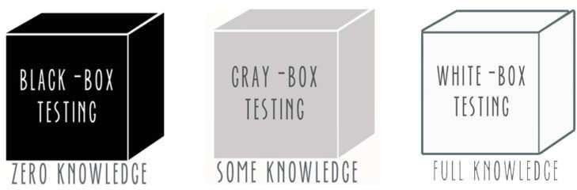

*Figure 19(3-5 Types of testing)*

Functional Testing Techniques

* Black-Box Testing
* White-Box Testing

##### White Box Testing

White box testing is a testing technique that examines the program structureand derives test data from the program logic/code. The other names of glassbox

testing are clear box testing, open box testing, logic driven testing or path driven testing or structural testing.

##### Advantages

* Forces test developer to reason carefully about implementation.
* Reveals errors in "hidden" code.
* Efficient in finding errors and problems
* Required knowledge of internals of the software under test isbeneficial for thorough testing
* Allows finding hidden errors
* Programmers introspection
* Helps optimizing the code
* Due to required internal knowledge of the software, maximumcoverage is obtained

##### Disadvantages

* Expensive as one has to spend both time and money to perform whitebox testing.
* In-depth knowledge about the programming language is necessary toperform white box testing. ❖ Requires high level knowledge of internals of the software under test
* Requires code access

##### Black Box Testing

Black-box testing is a method of software testing that examines the functionality of an application based on the specifications. It is also known as Specifications based testing. Independent Testing Team usually performsthis type of testing during the software testing life cycle.

This method of test can be applied to each and every level of softwaretesting such as unit, integration, system and acceptance testing.

##### Advantages

* Efficient when used on large systems.
* The tester and developer are independent of each other; testing isbalanced and unprejudiced. • Tester can be non-technical.
* There is no need for the tester to have detailed functional knowledgeof system.
* Tests will be done from an end user's point of view, because the enduser should accept the system. (This testing technique is sometimesalso called Acceptance testing.)
* Testing helps to identify vagueness and contradictions in functional specifications.
* Test cases can be designed as soon as the functional specifications arecomplete.

##### Disadvantages

* Test cases are challenging to design without having clear functional specifications.
* It is difficult to identify tricky inputs if the test cases are notdeveloped based on specifications.
* It is difficult to identify all possible inputs in limited testing time. Asa result, writing test cases may be slow and difficult.
* There are chances of having unidentified paths during the testingprocess.
* There is a high probability of repeating tests already performed by the programmer

##### Unit Testing

We wanted to test all pieces of the hardware/software components specially the basic components of the hardware/software to be sure that all the units of these components have been tested and they are working as expected. In an object- oriented environment, this is usually at the class level, and the minimal unit tests include the constructors and destructors. Unit testing ensures that each component of the software is working correctly and as expectedbut this happens separately. There is no any integration among these components. The main aim is to isolate each unit of the system to identify, analyse and fix the defects.

Technique used is White Box Testing.

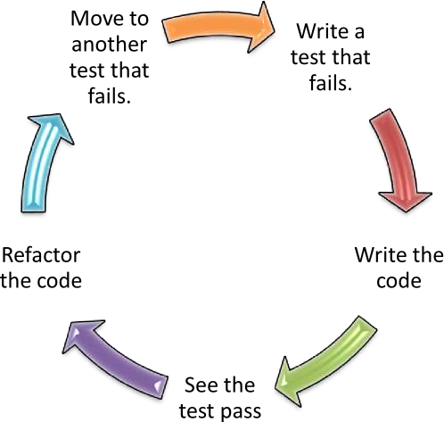

##### Integration Testing

Integration testing aims to see how two or more components are goingto work together to check if they are producing the expected output ornot, it aims to exposes any defects in the interactions between the components, also to discover if any issues in the interface that gathersthe integrated components. Progressively larger groups of tested software components corresponding to elements of architectural design are integrated and tested until the software works as a system.

It also verifies that the system is integrated to any external or third-party systems defined in the system requirements.

Upon completion of unit testing, the units or modules are to be integrated which gives raise to integration testing. The purpose ofintegration testing is to verify the functional, performance, and reliability between the modules that are integrated.

Integration Strategies used is Bottom up Integration

##### Bottom up Integration

Each component at lower hierarchy is tested individually and then the components that rely upon these components are tested.

##### System Testing

We can consider that the system testing is a BIG integration testingafter integrating all the components and the modules of the system together to verify that this system meets its requirements.

System Testing (ST) is a black box testing technique performed toevaluate the complete system the system's compliance against specified requirements. In System testing, the functionalities of thesystem are tested from an end-to-end perspective.

System Testing is usually carried out by a team that is independent ofthe development team in order to measure the quality of the system unbiased. It includes both functional and non-functional testing.

##### Acceptance Testing

Acceptance testing, a testing technique performed to determine whether or not the software system has met the requirement specifications. The main purpose of this test is to evaluate the system'scompliance with the business requirements and verify if it is having met the required criteria for delivery to end users.

##### Interface Testing

Interface Testing is performed to evaluate whether systems or components pass data and control correctly to one another. It is toverify if all the interactions between these modules are working properly and errors are handled properly. Handle network failures between Web site and application server.

##### Regression Testing

Regression testing is a black box testing technique that consists of re-executing those tests that are impacted by the code changes. These tests should be executed as often as possible throughout the software development life cycle.

##### Non-Functional Testing

Non-Functional testing is a software testing technique that verifies theattributes of the system such as memory leaks, performance or robustness of the system. Non-Functional testing is performed at all test levels.

##### Performance Testing

Performance testing, a non-functional testing technique performed todetermine the system parameters in terms of responsiveness and stability under various workload. Performance testing measures the quality attributes of the system, such as scalability, reliability and resource usage.

##### Performance Testing Techniques

* **Load testing**: It is the simplest form of testing conducted to understand the behavior of the system under a specific load. Load testing will result in measuring important business critical transactionsand load on the database, application server, etc., are also monitored.
* **Stress testing**: It is performed to find the upper limit capacity of thesystem and also to determine how the system performs if the currentload goes well above the expected maximum.
* **Soak testing**: Soak Testing also known as endurance testing, is performed to determine the system parameters under continuous expected load. During soak tests the parameters such as memory utilization is monitored to detect memory leaks or other performanceissues. The main aim is to discover the system's performance under sustained use.
* **Spike testing**: Spike testing is performed by increasing the number ofusers suddenly by a very large amount and measuring the performanceof the system. The main aim is to determine whether the system will be able to sustain the workload.
* **Load Testing**: Load testing is performance testing technique usingwhich the response of the system is measured under various load conditions. The load testing is performed for normal and peak loadconditions.

##### Objectives of Load Testing:

* Response time
* Throughput
* Resource utilization
* Maximum user load

##### Stress Testing

Stress testing a Non-Functional testing technique that is performed aspart of performance testing. During stress testing, the system is monitored after subjecting the system to overload to ensure that the system can sustain the stress.

The recovery of the system from such phase (after stress) is very critical as it is highly likely to happen in production environment.

##### Reasons for conducting Stress Testing

* It allows the test team to monitor system performance during failures.
* To verify if the system has saved the data before crashing or NOT.
* To verify if the system prints meaning error messages while crashingor did it print some random exceptions.
* To verify if unexpected failures do not cause security issues. StressTesting - Scenarios
* Monitor the system behavior when maximum number of users loggedin at the same time.
* All users performing the critical operations at the same time.
* All users accessing the same file at the same time.
* Hardware issues such as database server down or some of the serversin a server park crashed.

##### Endurance Testing

Endurance testing also known as Soak Testing is performed to determine if the application under test can sustain the continuous loads. Endurance testing, non- functional testing involves examiningthe system if it can withstand a huge load for a longer period of timeand thereby measuring the system's reaction parameters.

##### Volume Testing

Volume testing is a Non-functional testing that is performed as part of performance testing where the software is subjected to a huge volumeof data. It is also referred as flood testing.

##### Volume Testing Characteristics

* During development phase, only small amount of data is tested.
* The performance of the software deteriorates over time as there isenormous amount of data overtime.
* Test cases are derived from design documents.
* Test data is usually generated using a test data generator.
* Test data need not be logically correct but the data is to assess thesystem performance.
* Upon completion of testing, results are logged and tracked to bringit to closure.

##### Volume Testing - Checklist

* Verify if there is any data loss.
* Check the system's response time.
* Verify if the data is stored incorrectly.
* Check if the data is overwritten without any notification.

##### Usability Testing

Usability testing is a non-functional testing technique that is a measure of how easily the system can be used by end users. It is difficult to evaluate and measure but can be evaluated based on the below parameters:

* Level of Skill required to learn/use the software. It should maintainthe balance for both novice and expert user.
* Time required to get used to in using the software.
* The measure of increase in user productivity if any.
* Assessment of a user's attitude towards using the software.

##### Security Testing

Security testing is a testing technique to determine if an information system protects data and maintains functionality as intended. It alsoaims at verifying 6 basic principles as listed below:

* Confidentiality
* Integrity
* Authentication
* Authorization
* Availability
* Non-repudiation

##### Recovery Testing

Recovery testing is a type of non-functional testing technique performed in order to determine how quickly the system can recoverafter it has gone through system crash or hardware failure. Recoverytesting is the forced failure of the software to verify if the recovery issuccessful.

##### Resilience Testing

Resilience testing confirms that the system can recover from expectedor unexpected events without loss of data or functionality. Recovery testing confirms that the affected system can be restarted successfullyafter an outage.

##### Scalability Testing

Scalability is a performance testing parameter that investigates a system's ability to grow by increasing the workload per user, or thenumber of concurrent users, or the size of a database.

##### Compatibility Testing

Compatibility testing is a non-functional testing conducted on the application to evaluate the application's compatibility within differentenvironments. It can be of two types - forward compatibility testing and backward compatibility testing.

##### Other Testing

* **Database Testing**

Database testing involves the retrieved values from the database by the web or desktop application. Data in the User Interface should be matched as per the records are stored in the database.

##### Thread Testing

A thread is the smallest unit of work that a system can execute. Thread testing, a software testing technique used during early integration testing phase to verify the key functional capabilities thatcarry out specific task. These kinds of techniques are very helpful if an application is of type that uses client server architecture.

Performing Thread testing on valid business transaction through the integrated client, server and network is very critical. Threads are integrated and tested incrementally as subsystems and then performedas a whole system.

##### Concurrency Testing

Concurrency testing is also known as multi-user testing, performed toidentify the defects in an application when multiple users login to theapplication.

It helps in identifying and measuring the problems in system parameters such as response time, throughput, locks/dead locks or anyother issues associated with concurrency.

##### Stability Testing

Stability testing is a software testing technique adopted to verify if application can continuously perform well within or just above the acceptable period. It is a Non-functional Testing technique conductedas part of performance testing often referred as load or Endurance testing.

##### Reliability Testing

Software reliability testing is a testing technique that relates to testingthe ability of software to function given environmental conditions consistently that helps uncover issues in the software design and functionality.

##### Dependency Testing

Dependency Testing, a testing technique in which an application's requirements are pre-examined for existing software, initial states inorder to test the proper functionality. The impacted areas of the application are also tested when testing the new features or existing features.

##### Portability Testing

Portability testing is a process of testing with ease with which the software or product can be moved from one environment to another. Itis measured in terms of maximum amount of effort required to transfer from one system to another system. The portability testing is performed regularly throughout the software development life cycle inan iterative and incremental manner.

##### Test Automation

Software Test automation makes use of specialized tools to control the execution of tests and compares the actual results against the expectedresult. Usually, regression tests, which are repetitive actions, are automated. Testing Tools not only helps us to perform regression testsbut also helps us to automate data set up generation, product installation, GUI interaction, defect logging, etc. Automation tools areused for both Functional and Non-Functional testing.

##### Vulnerability Testing

Vulnerability testing, a software testing technique performed to evaluate the quantum of risks involved in the system in order toreduce the probability of the event.

## Testing Environment

Test Environment consists of elements that support test execution with software, hardware and network configured. Test environment configuration must mimic the production environment in order to uncover any environment/configuration related issues.

##### Factors for designing Test Environment:

* Determine if test environment needs archiving in order to takebackups.
* Verify the network configuration.
* Identify the required server operating system, databases and othercomponents.
* Identify the number of license required by the test team.

##### Environmental Configuration:

It is the combination of hardware and software environment on which the tests will be executed. It includes hardware configuration, operating systemsettings, software configuration, test terminals and other support to performthe test.

## Testing Results

#### Simulation Result: -

At first, we tried to connect every system individually at each stage we measure system readings & checking loads, and making them work in parallel

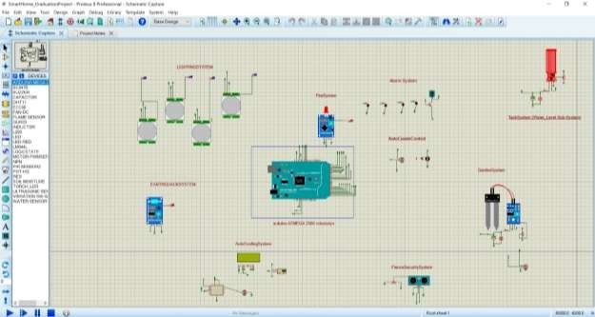

*Figure 20(3-6 Proteus Simulation)*

#### Software resaults: -

**Checking Bluetooth connectivity & searching for devices**

* + - Checking login validation
    - Checking password & email validation
    - On sign up checking that database is connected and send the data
    - Home id will be check in database

#### Hardware result :-

Testing every system individually at each stage measure system readings & checking loads, and making them work in parallel and ensure that every component of a system is operating as it should, and then test the whole system working together.

# Chapter 7: Conclusions & Recommendations

## Summary of achieved results

This project is based on the construction of a model simulating a home automation with different operation modes which can be controlled also by a mobile application.

To achieve this objective, a scale house that captures different signals, both digital and analog, has been developed. To approach the house to a real home automation application the variables under study and control are interior temperature and lighting, movement around the house and water level of the pool. The house has three main operating modes. In automatic mode, it performs the measurement and executes the control of the variables, regulating itself according to the conditions to which it is exposed. In contrast, the remote mode is achieved using the mobile application that allows user to modify the variables. Finally, in alarm mode it controls the parameters that assure the security of the house when proprietor is away from home.

To capture the signals, the prototype has temperature, lighting, movement and water level sensors installed, and for the regulation and control it has a fan, some LED, an acoustic warning device and a water pump. The core is an Arduino Mega board that allows the application operation and receives, from an Android mobile application, operating modes commands and, if it is operating remotely, orders to individually control the different actuators. For the data transmission from the mobile to the board, is used communication via Bluetooth.

## Possible extensions & Further developments

#### There are some extensions are considered to be done as a future workand they are:

* ADD Camera on the door (Videos and Images).
* Improve the performance by improving the hardware.
* Using image recognition to make camera recognize the stuff of the ground that surveillance to ignore non-threatening breaches on the fence from sending Alert/Notification to Mobile Application.
* Make a side admin system.
* Work on security to encrypt data that send to Database.

# Chapter 8: References

***All References used in documentation and project (Smart Home)***

1. [*"Getting Started: FOUNDATION > Introduction"*](https://www.arduino.cc/en/guide/introduction)*. arduino.cc.*
2. ^ [Jump up to:***a***](https://en.wikipedia.org/wiki/Arduino#cite_ref-kushner_2-0) [***b***](https://en.wikipedia.org/wiki/Arduino#cite_ref-kushner_2-1) [***c***](https://en.wikipedia.org/wiki/Arduino#cite_ref-kushner_2-2)*David Kushner (2011-10-26).* [*"The Making of Arduino"*](https://spectrum.ieee.org/geek-life/hands-on/the-making-of-arduino)*.* [*IEEE Spectrum.*](https://en.wikipedia.org/wiki/IEEE_Spectrum)
3. [**^**](https://en.wikipedia.org/wiki/Arduino#cite_ref-3) *Justin Lahart (27 November 2009).* [*"Taking an Open-Source Approach to Hardware"*](https://www.wsj.com/articles/SB10001424052748703499404574559960271468066)*.* [*The*](https://en.wikipedia.org/wiki/The_Wall_Street_Journal)[*Wall Street Journal.*](https://en.wikipedia.org/wiki/The_Wall_Street_Journal) *Retrieved 2014-09-07.*
4. ^ [Jump up to:***a***](https://en.wikipedia.org/wiki/Arduino#cite_ref-%3A0_4-0) [***b***](https://en.wikipedia.org/wiki/Arduino#cite_ref-%3A0_4-1)*Hernando Barragán (2016-01-01).* [*"The Untold History of*](https://arduinohistory.github.io/)[*Arduino"*](https://arduinohistory.github.io/)*. arduinohistory.github.io. Retrieved 2016-03-06.*
5. [**^**](https://en.wikipedia.org/wiki/Arduino#cite_ref-5) [*"How many Arduinos are "in the wild?" About 300,000".*](http://www.adafruit.com/blog/2011/05/15/how-many-arduinos-are-in-the-wild-about-300000/)[*Adafruit Industries.*](https://en.wikipedia.org/wiki/Adafruit_Industries) *May 15, 2011. Retrieved 2013-05-26.*